METPLANT TEMPLATE FOR PAPER
This page is a formatting example for the paper. Download and type into the paper template and the correct headings, font, spacing etc, will result.

When completed, delete any track changes and save the paper in WORD (.docx) format before submission.

Title of Paper

A Author¹, B Author², C Author³
- Affiliation, Position title, Organisation name, Address, Email address
- Affiliation, Position title, Organisation name, Address, Email address
- Affiliation, Position title, Organisation name, Address, Email address

Note: Presenting author’s name should be underlined.

ABSTRACT

Text here

INTRODUCTION

Text here

FIRST SECTION

Text here

Level 2 heading

Text here

Level 3 heading

Text here (not in italics)

SECOND SECTION

Text here
(Etc.)

Figures should be placed within the body of the paper soon after being mentioned.
Crop images to best reflect subject matter.
Insert image using ‘Image style’
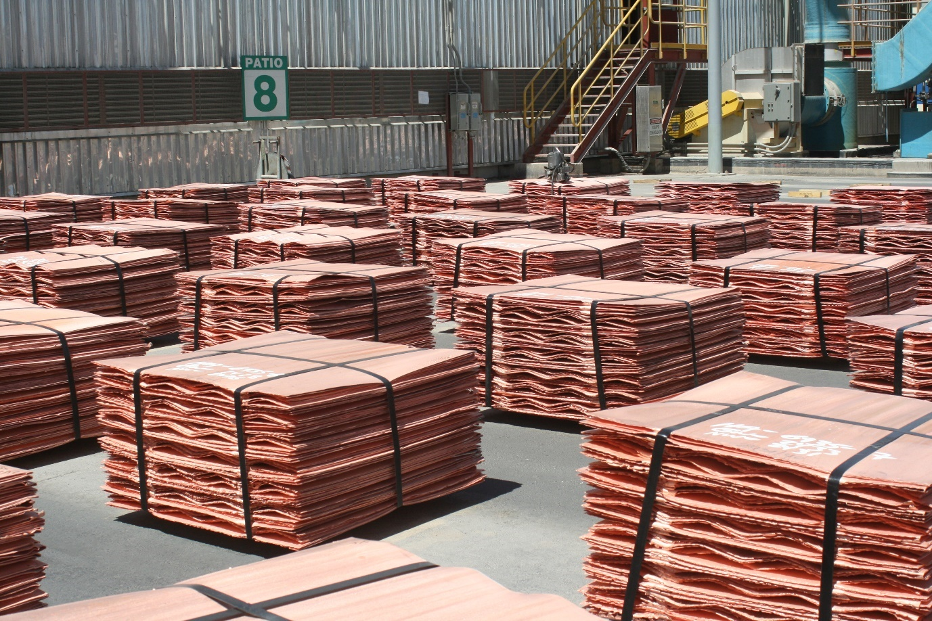
Figure 1 – Caption …
Tables should be placed within the body of the paper soon after being mentioned.
TABLE 1 – Caption …
Column 1 (Use ‘Table text header row’ style) | Column 2 | Column 3
X (Use ‘Table text’ style’) | 10 | 50
Y | 20 | 55
Z | 30 | 62
X | 40 | 50
Y | 60 | 50
Z | 20 | 35
x | 15 | 10

CONCLUSIONS

ACKNOWLEDGEMENTS

Note: please acknowledge collaborators here or anyone who has helped with the paper. It may also be appropriate to acknowledge company approval to publish. Please use third person language. i.e. The authors would like to acknowledge……………..

REFERENCES

Note: List references alphabetically by author surname. Do not use a numbered list. Refer to the MetPlant Guide to Authors for further instructions and information about the correct formatting of references.

