GUIDE TO AUTHORS

MetPlant 2026

Metallurgical Plant Design and Operating Strategies

Introduction
The papers for this conference will be published as an E-book and will made available on a password protected page of the Conference website for six months, after which the password protection will be removed.
The E-book Proceedings will be available to registered Delegates approximately one week before the Conference commences.
Papers must be submitted in electronic format, in Microsoft Word® using the MetPlant Paper Template (MetPlant 2026 paper template 251002.dotx).
Note that this template should be opened by double clicking on it outside Word (in Windows Explorer). This will create a *.docx Word file.
If you open it from within Word, you will open it as a *.dotx (template) file.
Any submission received that has not been generated using this template will be returned to the Author/s for insertion into a file created using the template.
This Guide to Authors has been prepared using the conference template and demonstrates the formatting style for the conference papers.
The paper number assigned via the abstract submission portal is used in the acceptance letter, the copyright form and for other administrative purposes only. Please do not use this number on any draft or final copy of your paper or in other correspondence.

GUIDELINES FOR PREPARING PAPERS
Authors are required to follow the formatting guidelines below. The paper should not exceed 8000 words. The paper and the Conference will be presented in English.
When you have opened the template by double-clicking on the *.dotx file, save the newly created document with a new name and type your paper into it. Ensure that you delete the instructions in red (e.g., Text here) as you type your text.
The Normal style is 10-point (“pt”) Arial, with a 12 pt space between paragraphs. The heading styles are covered in Appendix 2 (Headings; page 19).
Also ensure that you remove all traces of Track Changes and comments before you submit your paper.

Paper Quality
Please note:
- we will only accept original submissions to conferences; papers published elsewhere must be significantly changed by updating
- papers must have a strong technical and/or site-based component
- we do not accept promotional papers of any kind
- it is the authors’ responsibility to allow adequate time to seek and receive permissions for publishing information (internal within your organization or externally from sponsoring companies) – extensions are limited
- papers must comply with the Joint Ore Reserves Committee (“JORC”) code, or equivalent Committee for Mineral Reserves International Reporting Standards (“CRIRSCO”) code, if they contain information that relates to Mineral Resources and Mineral Reserves. This is the authors’ responsibility
- you must advise us if you have used any “artificial intelligence” (AI) programs in the preparation of your paper. It does not necessarily mean that your paper won’t be accepted but you must declare the nature of the use of any AI.

Responsibilities of Authors
It is the responsibility of the author(s) to ensure the correctness of the technical content of their paper, including presentation of facts, dates, claims made, et cetera (“etc”) and that they have followed the instructions and the layout required by this Guide to Authors.

Refereeing of Papers
Papers will be refereed by the Convenor, Organising Committee and the Peer Review Team and returned to the nominated author by the Convenor with comments including any action required.

Authors with English as a second language
We encourage international authors to make use of an English editor before submission or the paper may not be accepted.

Writing Style
The paper should be written in clear, concise English, in the active voice where possible. That is (“i.e.”), use personal pronouns when describing actions taken by the authors (for example, “We took samples from …”). The active voice is normally a shorter way of writing (compare “John threw the ball”, which is the active voice, with “The ball was thrown by John”, which is the passive voice).
Avoid colloquial expressions and jargon.
Remember that you are not writing a novel; the objective of your paper is to communicate, and some of your readers might be using English as a second language.

Verb tenses
Use the present tense to describe actions, conditions, results, and conclusions with ongoing applicability in the present. Use the past tense to describe actions, conditions and results that occurred in the past. For example, “We ground the samples to a P₈₀ of 250 µm for the flotation tests” and “Our results show”.

Abbreviations
Abbreviations must conform to normal standards and be spelled in full the first time and the abbreviation given in parentheses inside double quotation marks, for example (“e.g.”). Remember that initialisms and acronyms may not necessarily understood by everyone, even in the same industry (e.g., certified reference material (“CRM”), critical risk management (“CRM”), and customer relations management (“CRM”) software).
If you have defined an abbreviation, all subsequent uses should be the defined abbreviation unless it is at the beginning of a sentence. For example, do not write “E.g.” at the beginning of a sentence.
Don’t abbreviate terms that appear fewer than three times in the paper unless they are commonly accepted units or symbols.
Table 9 (page 32) in Appendix 3 provides examples of commonly used abbreviations.

Punctuation
Follow modern convention by using minimal punctuation. This particularly applies to abbreviations and initials (e.g., write “USA” not “U.S.A” and do not use a full-stop after an abbreviation that ends in the final letter of the word, i.e., “Dr” not “Dr.”).
Note that the forward slash (‘/’) is used only to mean a choice between two words (e.g., “and/or”) and does not imply a connection between the words.
Apostrophes are used for possessive nouns or contractions; they are not to be used in plurals or dates. That is (“i.e.”), do not write 1990’s or KPI’s; instead write 1990s and KPIs.
Use double quotation marks (“ ”) instead of single quotation marks (‘ ’).
Refer to a dictionary to determine whether compound words (two words that describe one item) are written as two separate words, hyphenated, or one unbroken word.
For compound words that do not appear in the dictionary, use a hyphen if the term can be misread or it expresses a single thought (e.g., iron-ore deposit, open-pit). Table 8 (page 31) in Appendix 3 provides some examples.
Full-stops and commas come after quotation marks or parentheses.

Units and symbols
All units of measurement must be in the metric form and should be abbreviated as specified in the International System of Units (SI: Systeme International d'Unités). This includes leaving a space between the numbers and the units (e.g., 5 kg/m³).
Use a hard space (Shift + Ctrl + Spacebar) to stop the unit separating from the number at the end of a line. Note that a hard space is a non-printing, hidden character that looks like a degree symbol when the hidden characters are revealed.
Write t/y for tonnes per year, not tpy nor tpa.
Do not leave a space when using symbols, such as $ or %, except for the degrees symbol when writing temperatures (e.g., 1200 C). Again, use a hard space to keep the number and degrees symbol together.

Trademarks and copyright symbols
Trademarks are very important to their owners. If a trademark is used in everyday language, it becomes a generic term. When using a trademarked item (e.g., Fiberglas®), note that it is a trademark with either superscripted “TM” or “®”.
The same applies to the copyright symbol “©”.

Listing points in the text
When listing items of importance, show as bullet points. Do not use continuous text separated by commas or semicolons.
Items in bulleted lists should begin with lower case letters and only the last one has a full stop. The other items on the list should not be terminated with a semicolon or comma, and do not use “and” at the end of the penultimate item in the list.
Create your bulleted lists with a 6.3 millimetre (“mm”) indent from the left margin and hanging by another 6.3 mm. The first bullet point has a space before of 12 pt. If the bullet points are all in a single line, do not leave a space between each point. However, if one or more bullet points take several lines, use a 6 pt space ahead of each point. Figure 9 (page 22) in Appendix 2 shows the settings for single bullet points.
The lead-in paragraph for a bulleted list must have the Keep with next property (see Keep with Next in Appendix 2; page 22) turned on so that it does not separate from the first item of the list at the bottom of a page. The introductory paragraph concludes with a colon; never introduce a bulleted or numbered list with a semi-colon.
For example:
These changes to the circuit resulted in the following advantages:
- increased recovery
- increased grade
- decreased reagent consumption.

Numbers
Use numerals for all units of measurement that involve abbreviations, e.g., 4 km, 2 cm. Spell out numbers from one to ten when used without a unit. Use numerals for 11 and above. Do not use commas or spaces for figures between 1000 and 9999. Numbers above 10 000 have a hard space and not a comma or full stop (to limit confusion arising from the alternate uses of commas and full stops to indicate a decimal point).
All numbers at the start of a sentence must be spelled out. Express all fractions as decimals, e.g. 2.5 or 3.75.

Formulae
Mathematical and chemical formulae should be carefully typed, using an equation-creating function in Microsoft Word. The author is responsible for ensuring that all symbols, equations, etc are correctly reproduced in the final electronic version submitted for publication in the E-book.
Numbers in chemical formulae must be subscripted or superscripted. Write Fe₂O₃ and Nm³/s, not Fe2O3 and Nm3/s.

Some notes on spelling and grammar
Note that the spelling sulfur is to be used rather than the obsolescent sulphur, and so with its derivatives (sulfuric, sulfide, etc).
Flow sheet, flow chart and test work should be written as separate words rather than single ones.
Note that criteria, data, and media are the plurals of criterion, datum and medium. They should be treated as such. Writing medias and criterias is grammatically incorrect.
Table 1 – Examples of correct and incorrect grammar
Correct | Incorrect
The design criteria are listed in Table 3. | The design criteria is listed in Table 3.
Several different grinding media were tested. | Several different grinding medias were tested
The grinding medium is discharged from the ball mill along with the feed. | The grinding media is discharged from the ball mill along with the feed.

General comments
Please use:
- short sentences are preferred to long sentences
- short words are preferred to long ones (e.g. use method not methodology and affects not has an impact on)
- avoid writing in order to or in order for, as these are just longer ways of saying to and for
- use several rather than a number of, and if possible, give the number instead. Numbers are preferred over vague statements (e.g., “Reducing the regrind mill P₈₀ to 7 µm increased flotation recovery by 3%” rather than “Changing the grind size had a significant impact on flotation recovery”)
- Australian spelling (e.g., capitalise not capitalize)
- page numbers at the centre of the page header
- a maximum of two figures or tables per 1000 words
- the template provided
- the paper sequence, as outlined above
- capitalised nouns followed by numbers or letters (e.g., Trial 3, Figure 1, Table 4), unless the noun represents a common part of a book or table (e.g., in column 3 on page 2).
Please do not use:
- gendered or sexist terms
- extra returns (the Enter key) between paragraphs or double spaces (even after full stops)
- colloquial language
- excessive exclamation marks
- unreferenced quotes
- unexplained abbreviations (always spell out first usage)
- lengthy paper titles and/or subtitles (max 25 words)
- excessive capitalisation (e.g., “in the 20th century…” not “in the 20th Century…”; “in the blast furnace…” not “in the Blast Furnace…”; “the Mount Isa copper mine” not “the Mount Isa Copper Mine”)
- use section breaks, hard page breaks, or press the Enter key multiple times to force text, tables or figures to a new page (these all make formatting more difficult during editing).

document format
The template has been created in the required format.
Appendix 2 (page 18) provides the details.
If you use the template as instructed, you will meet the MetPlant Conference requirements.

Normal text
The font is black, 10 pt Arial, with a 12 pt space between paragraphs, single line spacing and no indents. This means that you need only press the Enter key once to create a new paragraph.
The text alignment is Justified. The Widow/Orphan control property is switched on, so there will be no problems with a single line of a paragraph appearing at the top or bottom of a page.
To make text the Normal style, select the Normal style from the Home ribbon (see Figure 1) or press the N key while holding down both the Shift and Ctrl keys (that is, Shift + Ctrl + N).
Figure 1 – Selecting the Normal style

Title page

Title of paper
Table 2 shows the format settings for the title of the paper.
Table 2 – Format settings for the title of the paper
Property | Setting
Font | Arial
Font size | 12 pt
Font colour | Black (Automatic)
Bold | On
Alignment | Centred
Capitalisation | All capitals

Authors, organisation, position title and contact details
Table 3 shows the format settings of the list of authors, and the organisations, position titles and contact details lines. The list of authors will contain only the first initial and surname of each author.
Where there are multiple authors, include a superscripted note number for each so that they can be linked to the position title and email address.
Please underline the presenting author.
Table 3 – Format settings for the list of authors, affiliations, positions and contact details
Property | Setting
Property | Authors’ names | Position, contact details, etc
Font | Arial | Arial
Font size | 10 pt | 10 pt
Font colour | Black (Automatic) | Black (Automatic)
Bold | Off | Off
Italic | On | Off
Space before | 10 pt | 0 pt
Alignment | Centred | Centred for a single author, with no note numbers; left with a 13 mm indent for multiple authors

Position title and contact details
Table 4 shows the format settings for the position title and email address line. The note number in this line is not superscripted, but is separated from the position title by a full stop and a single space.
Table 4 – Format settings for the position title and contact details of the authors
Property | Setting
Font | Arial
Font size | 10 pt
Font colour | Black (Automatic)
Bold | Off
Italic | Off
Space before | 0 pt
Alignment | Centred for a single author with no note numbers; left with a 1.3 cm indent for multiple authors

Example:

Title of Paper
A Author¹, B Author², C Author³
1. Position title, Organisation name, Address, Email address
2. Position title, Organisation name, Address, Email address
3. Position title, Organisation name, Address, Email address

Headings
Up to five levels of headings may be used in the papers. They may be applied by selecting the heading level from the Styles menu on the Home ribbon (see Figure 1, page 6).
Alternatively, a key board shortcut can be used: Ctrl + Alt + 1 for Level 1 headings, Ctrl + Alt + 2 for Level 2 headings, and so on).
A 24 pt space shall be used ahead of Level 1 headings, an 18 pt space ahead of Level 2 and Level 3 headings and a 12 pt space should be left ahead of the other headings.
Please do not use numbers in the headings.
Examples of headings are given in Appendix 2, on page 19.

Figures, Photographs and Tables
Figures, photographs and tables should be incorporated into the body of the paper as close as possible to the text in which the first reference is made.
Drawings and photographs are to be captioned as “Figure”. Tables are captioned as “Table”.
When figures, photographs or tables are included in the document, their meaning should be obvious from the text.
Guide the reader through the key points you expect the reader to glean from the figures, tables or text.
Short explanatory notes (preferably one line) can be added as footnotes to illustrations, appearing immediately below the illustration and not at the bottom of the page.
Should you do this, the figure or table above the explanatory note must have its Keep with next property switched on (see Keep with Next in Appendix 2; page 22) to prevent the explanatory note separating from the table or figure at the bottom of a page.

Drawings
Drawings prepared with a drawing package must be embedded in the text.
Do not embed them as file links, as the connection will be broken and the drawing will disappear if the document is updated.
In some older versions of Word, the default version of copying and pasting a drawing or Excel chart into a document resulted in the underlying data being embedded with it. This allows the drawing or chart to be edited within Word.
However, it has two downsides:
- having a large spreadsheet file embedded in Word increases the size of the Word file, and this would happen every time a chart from the same spreadsheet was pasted into the Word file, making the Word file size unwieldy very quickly
- while the author was willing to share the chart, some of the other data in the spreadsheet might have been confidential, but it could be seen by a reader sufficiently knowledgeable in the use of Word.
Recent versions of Word still allow this option, but it is no longer the default.
Accordingly, make sure that the drawings are not pasted into Word using the Microsoft Excel Chart Object (or similar from other packages) option.
Drawings prepared with thin lines and small lettering or hand drawn are not of adequate quality and are not to be used.
Labels in drawings must be large enough to read when embedded in the document (suggested size is equivalent to 9–11 pt after embedding).

Tables
Tables will have vertical and horizontal grids composed of single lines (e.g., Table 4; page 7). Each paragraph of text will have a 2 pt space before and after.
The cells in the first column, with the exception of the last row, will have the Keep with next property switched on (see Keep with Next in Appendix 2; page 22).
Units of measurement, properly abbreviated and bracketed, should be placed at the top of columns or column 1 headings rather than in the body of the table.
The conference template includes a conference style. A table can be formatted to this style by selecting it from the MetPlant table style on the Table Design ribbon (see Figure 2; the MetPlant table style is the one on the left end of the Table Styles menu). To use this style, create the table, select the whole table and then click on the MetPlant table style.
Figure 2 – The MetPlant table style
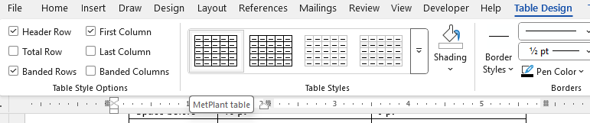

Captions
All captions are to appear above the figure, photograph or table to which they refer.
This is because the Caption style has been formatted with the Keep with next property on, so that captions will automatically follow the table onto the next page.
If the captions are below the object to which they refer, they will instead stay with the following paragraph rather than that object. This can lead to a figure appearing at the bottom of one page and its caption at the top of the next one.
The Caption style is formatted to use Arabic numerals (Figure 1, Table 3). The character following the figure or table number must be an en dash. This will create automatically if you leave a space after the number, type a hyphen, leave another space and then type a word.
Captions are to be created using Word’s Insert Caption feature, which is available in the References ribbon (see Figure 16 in Appendix 2; page 26). Using this will generate a caption with a unique number (e.g., Figure 16). It also allows Cross-references to be created (see Figure 18 in Appendix 2; page 27).
If a new caption is created ahead of an existing caption, the captions existing after that point will automatically renumber. No automatic renumbering will occur if the captions are subsequently deleted or moved. The captions will need to be manually renumbered. This is done by selecting the captions and pressing the F9 key. Since doing this for every caption would be tedious, the easiest way is to select the entire document (Ctrl + A) and then pressing the F9 key. This will also update all the cross-references.
When you create a caption, Word will have an ordinary space between the label and its number. Delete this space and replace it with a hard space. When you create a cross-refence to the caption, this hard space will be reproduced in the cross-reference and it will stop the label and its number separating at the end of a line.

Cross-references
All references to figures, photographs and tables must be Word cross-references.
Cross-references have one significant trap: once they have been created, any insertion of text immediately in front of the caption becomes part of the caption and will be reproduced throughout the document wherever the cross-refences appear when the cross-references are updated.
So do not insert text or page breaks immediately before a caption.
Cross-references do not automatically update when a caption number is changed by insertion, so they must be manually updated using the F9 key.
Cross-references are hyperlinks, so clicking on them will cause the cursor to jump to the caption (the Word default is clicking on hyperlinks while pressing the Ctrl key). This will make it easier for readers to jump to a figure or table.
Readers can then jump back by pressing the Alt and back arrow keys together.

REFERENCES
References are to appear as footnotes on the pages in which the first reference is made. If you refer to the same reference later in the paper, do this by a Word Cross-reference (see Figure 20 in Appendix 2; page 28).
Footnote numbers, and cross-references to them, are to be placed immediately after punctuation marks. If cross-references to footnote numbers are placed at the end of a word, Word might flag it as a spelling error.
Leave a space between the footnote number at the bottom of the page and the first letter of the text.
Where multiple reference numbers are used for a statement, insert a superscripted comma between them. When the footnotes are initially created, each reference must have a unique number.
Footnote numbers will automatically update as new ones are added or existing ones deleted. Cross-references to footnotes will not automatically update and must be updated manually (see Cross-references; page 9).
Using footnotes for references makes it easier for the reader to scan them when they are referred to in the text. They also avoid having long lists of names and dates in the text when there are multiple references being referred to, and it avoids confusion when there are citations to multiple papers published by an author in the same year.
If you hover your cursor over a footnote reference in the text, it will display the contents of the footnote. If you click on a cross-reference to a footnote, it will take you to the original occurrence of the footnote. Pressing the Alt and back arrow keys together will return you to the point of the document from which you came.

Formats of References
Authors’ names are to be written with their initials first, and full stops immediately following each initial, but no space between the full stop and the following initial.
A continuous run of pages has the first and last number separated with an en dash, but if there is a break at the beginning or the end of the run, use a comma to indicate the break.
Examples that must be followed appear below. The examples appear as footnotes.

Books
The author’s name is separated from the title by a comma. The title appears in italics, with capitalization of the initial letters of words, apart from those of articles, prepositions or conjunctions. The title is followed, in parentheses, by the name of the publisher, its location and the publication date. Finally, the pages in which the cited information can be found.
Where a book is edited rather than authored, the format is the same, except that the word “Ed” (or “Eds” if there are multiple editors) appears between the book editor’s name and the book title.

A chapter or paper by an author in a book edited or compiled by others
The author’s name comes first, followed by the title of the chapter. The title is written in normal text, with introductory and concluding quotation marks. The book containing the chapter is introduced by the word “in”. Its title is in italics and followed by the publisher’s name and location, the publication date, and the page numbers.

Papers in conference proceedings
The format is similar to citations of papers in books.

Articles in journals, magazines or other periodicals
The name of the article appears in quotation marks. The name of the journal or magazine appears in italics. The volume number is bold and is followed by the issue number in parentheses, page range and then the date in parentheses.
In some cases, magazines or periodicals do not have a volume number.,

Early online publication ahead of print
Substitute the digital object identifier (“DOI”) for the volume, issue and page numbers.

Work accepted for publication but not yet published
State the author’s name, the title, the journal in which it is to be published and note in parentheses that it is “in press”.

Theses
Write the author’s name, the title of the thesis and the name of the university, but not the degree. Name the city if the university could be mistaken for another (e.g., the University of Newcastle).

Personal communications
State the name of the individual cited, write “personal communication” and the date.

Patents
State the name of the inventor, the title of the patent, the patent number and the Patent Cooperation Treaty (“PCT”) number, and the publication date of the accepted application.

Material available to download on a website
State the author’s name (if available), the title of the report, paper or other item, the date of publication (the last update given), and provide the web address.
Note that if you copy a web address and paste it into Word, Word might automatically convert the address to a hyperlink with a name that would not be obvious to the reader. For example, the web address cited in the footnote for this example would appear as the unhelpful mcs2025.pdf - Mineral Commodity Summaries 2025.17 To avoid this, paste the link into the footnote using Shift + Ctrl + V rather than the normal Ctrl + V.
If you type a space immediately after the web address, it will convert to a hyperlink but display the underlying web address so that a reader could copy it, if necessary.17
Include the date you access the web site, as the contents might change before a reader tries to access it.
If you prefer to use a mouse for pasting, select the down arrow under the Paste clip-board on the Home ribbon, and then select the Keep Text Only (T) button, usually at the right of the presented options (see Figure 3).
Figure 3 – How to paste unformatted text
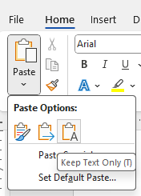

Paper presented at a conference but not formally published
List the conference at which it was presented.

Manuscript in preparation
Type “in preparation” at the end of the reference.

Printed material with a restricted or intermittent circulation
This might vary a little, depending on the item. The example is a reference to a maps explanatory notes. Try to make the references consistent with the styles of other examples presented.

SUBMISSION OF your abstract or PAPER
The following points provide details for the submission of papers.
- A COVERING LETTER with the title of the paper, the name(s) of author(s), the publication for which the paper is submitted, and the name of a contact person with full postal address and telephone/fax/e-mail numbers.
- The COVERING LETTER shall also contain confirmation that the publication has been approved by all relevant companies where technical content or discussion refers to specific operations or physical or intellectual properties of those companies.
- The COPYRIGHT ASSIGNMENT shall also accompany the COVERING LETTER.
- The PAPER FOR THE EBOOK, beginning with the title of the paper, the name(s) of the author(s), their affiliations and all company and contact details, the Abstract, and continuing straight into the Introduction and the body of the paper, with no hard page break.
Papers shall contain a list of references, and acknowledgements (if appropriate).

Submission addresses
Online submission for abstracts must be submitted through the MetPlant 2026 Conference Speakers' Portal on the conference website: https://www.metplant.com.au/
Submission of first and subsequent draft full papers, extended abstracts and posters must be emailed to janine@metval.com.au with a cc to chris@metval.com.au.
Once you have been advised by the Convenor that the paper is final it should be submitted again through the MetPlant 2026 Conference Speakers' Portal on the conference website: https://www.metplant.com.au/

PAPER CHECKLIST
The following points are offered as a final checklist for your paper:
- ensure that you have company and/or management approval to submit and publish the paper (as appropriate)
- run the spelling and grammar checker through the document, paying particular attention to words and phrases the grammar checker highlights; the grammar checker makes mistakes, but it often highlights problems that you might not have noticed
- reread the Guide to Authors and compare it to your paper’s formatting to make sure the paper’s formatting complies with the conference template
- read the document from beginning to end to make sure that it presents a logical case, that there are no unfinished thoughts or sentences, and that all abbreviations have been defined at first use (and only on first use)
- use Ctrl F to search your paper for commonly mis-used words that won’t be picked up with the spell check function. Some examples of these are:
- trial and trail
- from and form
- above and below (should be aforementioned and subsequent or directly referenced as the referenced section may not actually be above or below in the final published version).

GUIDELINES FOR PRESENTING PAPERS AND AUDIO–VISUAL AIDS

General
Present only the highlights of your paper. Do not attempt to present all the detail in the paper.
Your presentation should be interesting enough to make people want to read the paper for the full details. It is useful to tell the audience the significance of the work at the beginning of the presentation as this will help retain attention.

Preparation
Use simple language where possible and be informative in a practical sense.
Analytical and mathematical data are difficult to absorb when presented orally and often confuse the listener. Visual aids are a valuable tool in helping keep the material sufficiently simple to be easily understood by the audience.
It is usually better to convert tables to charts or graphs, showing trends rather than the detail. Each slide should attempt to convey only one idea, such as a trend, a relationship, a comparison, e.g.:
- line graphs to show trends and relationships
- bar graphs to compare magnitudes
- pie graphs to show distributions
- schematic diagrams to show circuits, flows and processes
- photographs to show detail not readily prepared in other ways (microstructures, special arrangements if important, etc)
- tables - use only as a last resort and then with a minimum number of items (in such cases, use a font size that can be read from the back of the room when projected onto the screen).
The following audio–visual (“AV”) equipment will be available:
- PowerPoint data projection
- podium and lapel microphones
- an AV technician.
Do not read out numbers and other data from tables. Tell the story they represent.

Content (presentations by or about a company or organisation)
Papers that discuss the merits of a particular company, its equipment or process(es) are not acceptable. Papers presented must demonstrate adequate scientific and technical data (or case studies in pilot plant or plant operations) of equipment use and/or processes developed; if in so doing they mention a particular company, its equipment and/or processes, this must be an adjunct and not the main theme of the paper.
Presentation of a paper is not to be used as an occasion for marketing or promoting specific company interests.

PowerPoint electronic presentation
Limit each slide to one main idea or objective. Limit each slide to a maximum of 10 words. Do not take the management consultant approach of densely packed slides.
Limit the total number of slides (excluding the title slide) to no more than one slide per minute.
Images should be based on the use of contrasting colours. Try not to use too many colours at once. Some colour combinations do not provide enough contrast for the audience to read, e.g. red text on a green or yellow background, and avoid using green and yellow lines to distinguish between two data series on graphs.
Do not use borders to emphasise individual elements as this creates confusion.
Beware of using too many fonts. Use a maximum of two fonts per slide – one font for headings and one for text. Don’t highlight individual words with a different font. Don't use italics.
Bring your presentation on a memory stick. Personal laptops will not be connected to the AV system.
Please have a back-up copy of your presentation on another memory stick.
There will be set times in advance of each session made available to each presenter to test the equipment. These times will be conveyed to the presenter at registration.

Presenting the paper
Speakers should present their papers in a relaxed manner. Go over your paper several times beforehand and be familiar enough with it to look up from time to time and keep in contact with your audience.
During the discussion period, if you feel the audience did not hear the question, repeat it first, and then answer it.
Plan to end the presentation two to three minutes earlier than the allocated time. You will not be permitted to talk beyond this allocated time.
A few ideas well expressed will create the best impression.
If every speaker follows these guidelines, the sessions will be very effective and each paper, including yours, will be better appreciated.

PRESENTERS’ CHECKLIST
Prepare and practise your oral presentation and presentation material to check your delivery time.
Provide your presentation on a memory stick or USB drive to the AV technician for loading, preferably at the authors’ briefing session but no later than the break before the beginning of your session.
Present paper in time allocated, leaving several minutes for discussion and questions.
Appendix 2

How to use word to meet the conference requirements

Paper Size
The papers are to be written using the A4 paper size: 210 mm x 297 mm.

Margins
Table 5 shows the margin settings to be used.
Table 5 – Margin settings
Margin | Size  (centimetres) | Size  (inches)
Top | 2.54 | 1.0
Left | 2.54 | 1.0
Bottom | 2.54 | 1.0
Right | 2.54 | 1.0

Normal Text
Figure 4 shows the paragraph settings for the normal text in the paper.
Figure 4 – Paragraph settings for normal text
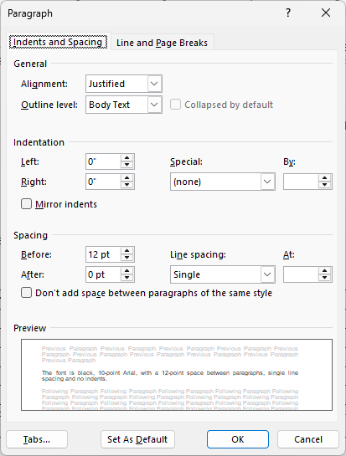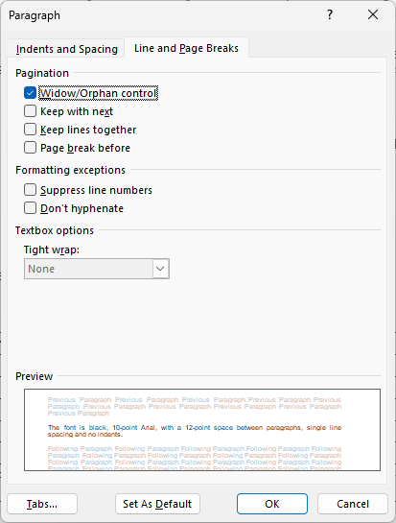

Headings
Examples of headings and their properties.

FREE-STANDING BOLD CAPITALS IN CENTRE (level 1)
The keyboard shortcut for Level 1 headings is: Ctrl + Alt + 1.

Free-standing, Bold at Side (Level 2)
The keyboard shortcut for Level 2 headings is: Ctrl + Alt + 2.

Free-standing lower-case italics at side (Level 3)
The keyboard shortcut for Level 3 headings is: Ctrl + Alt ₊ 3.

Free-standing, underlined lower-case at side (Level 4)
The keyboard shortcut for Level 4 headings is: Ctrl + Alt + 4.

Free-standing lower-case at side (Level 5)
The keyboard shortcut for Level 5 headings is: Ctrl + Alt + 5.
Table 6 shows the font format settings for the Level 1 and Level 2 headings. Paragraph format settings are shown in Figure 5 (Level 1 headings), Figure 6 (Level 2 and Level 3 headings) and Figure 7 (Level 4 and Level 5 headings).
Table 6 – Font format settings for Level 1 and Level 2 headings
Property | Setting
Property | Level 1 | Level 2
Font | Arial | Arial
Font size | 10 pt | 10 pt
Font colour | Black (Automatic) | Black (Automatic)
Bold | On | On
Italic | Off | Off
Space before | 12 pt | 12 pt
Capitalisation | ENTIRELY IN UPPER CASE | Capitalise the first letters, apart from conjunctions (e.g., “and” and “or”), prepositions (e.g., “of” and “on”), and articles (“the”, “a” and “an”).
Figure 5 – Paragraph format settings for Level 1 headings
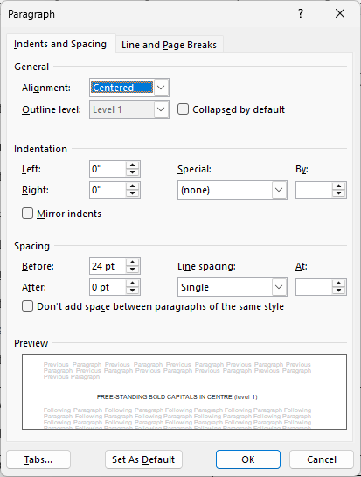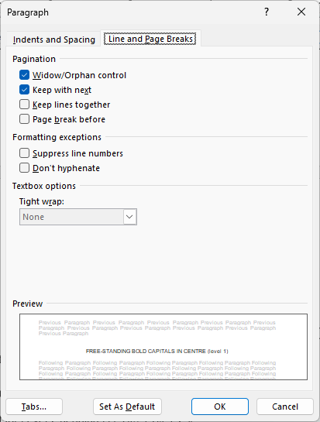
Figure 6 – Paragraph format settings for Level 2 and Level 3 headings
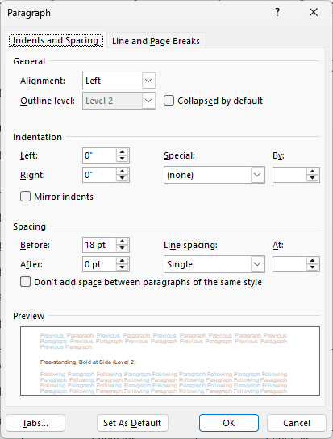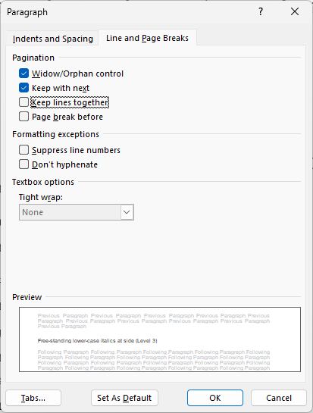
Figure 7 – Paragraph format settings for Level 4 and Level 5 headings
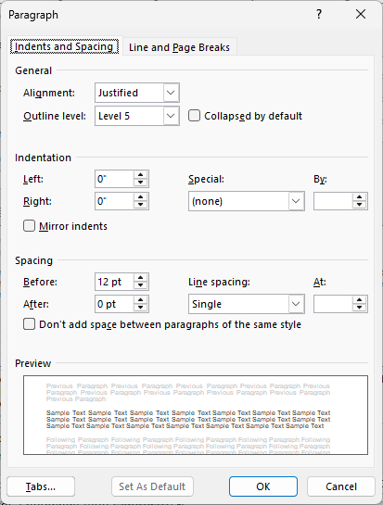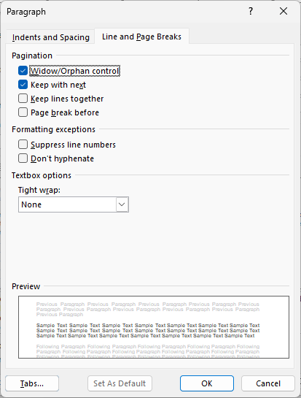
You can open the Paragraph dialog box by clicking on the small down arrow in the bottom left corner of the Paragraph options on the Home ribbon of Word. Alternatively, it can be opened from the keyboard by briefly holding down the Alt + O keys, releasing them and then pressing the P key.
Figure 8 – To open the Paragraph dialog box
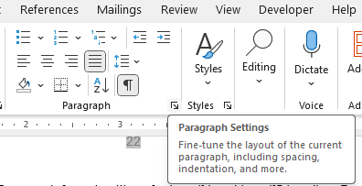
Table 7 shows the font format settings for Level 3, 4 and 5 headings.
Table 7 – Font format settings for Levels 3, 4 and 5 headings
Property | Setting
Property | Level 3 | Level 4 | Level 5
Font | Arial | Arial | Arial
Font size | 11 pt | 10 pt | 10 pt
Font colour | Black (Automatic) | Black (Automatic) | Black (Automatic)
Bold | Off | Off | Off
Italics | On | Off | Off
Underline | Off | On | Off
Capitalisation | Only the first letter of the heading and the first letter of proper nouns capitalised

Bullet Points
Figure 9 shows the format for bullet points.
Figure 9 – Format for bullet points
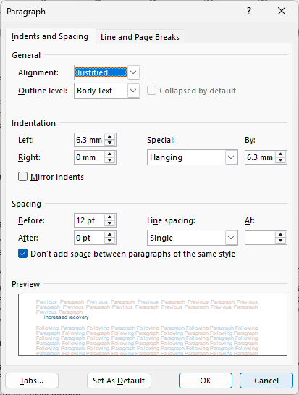

Keep with Next
The Keep with next property keeps one paragraph on the same page as the next one. This stops headings, captions and other items being stranded at the bottom of the page when the following paragraph moves to the next page (see Figure 10).
A commonly used method to avoid this is to hit the Enter key repeatedly until the heading follows the paragraph onto the next page. Figure 11 shows the result, with the paragraph marks showing above the heading “Keep with Next”. The paragraph marks are hidden text, visible because I switched on the Show property.
This approach works until you add or delete some text earlier in the document, and then the space you created is in the wrong place, and you have to remember to delete the paragraph marks. If you use Keep with next instead, the heading will automatically follow the paragraph onto the next page and there is no need to add spaces using the Enter key, nor remove them later if you change text on earlier pages.
Figure 10 – Heading dangling at the bottom of a page
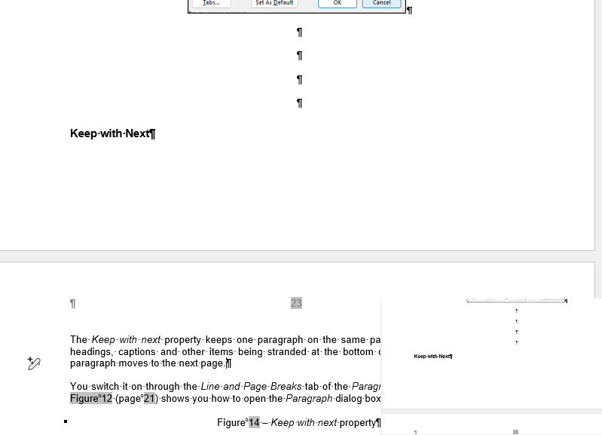
Figure 11 – With Keep with next property switched on
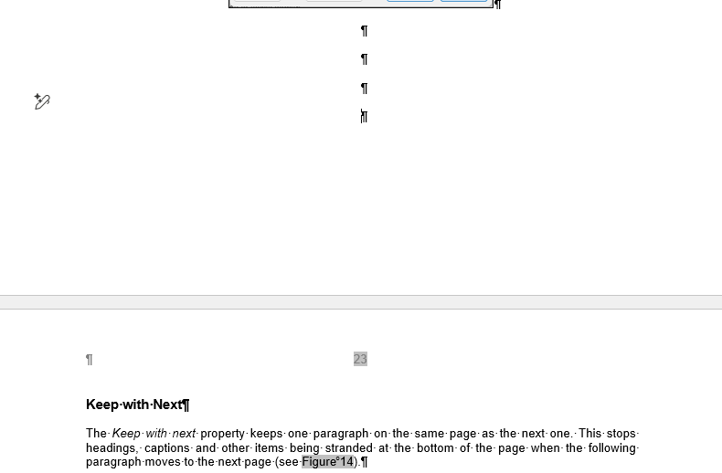
You switch the Keep with next property on through the Line and Page Breaks tab of the Paragraph dialog box (see Figure 12). Figure 8 (page 21) shows you how to open the Paragraph dialog box.
Figure 12 – Keep with next property
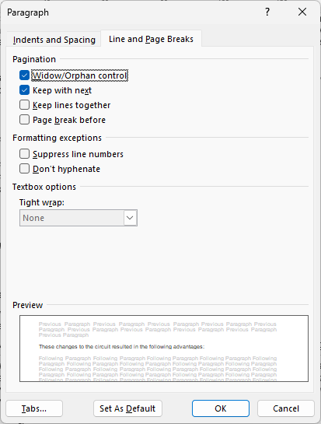
There is no default keyboard shortcut for Keep with next. I create my own (Alt + K). You can do this by selecting the Customize… button for Keyboard shortcuts. First, open the Word Options dialog box by selection Options, which is at the bottom left of the File tab, the left-most tab of the menu (see Figure 13). This opens the Word Options dialog box. Then select the Customize Ribbon option (see Figure 14)
Figure 13 – The File tab
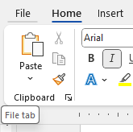
Figure 14 – Finding the Keyboard shortcuts Customize button
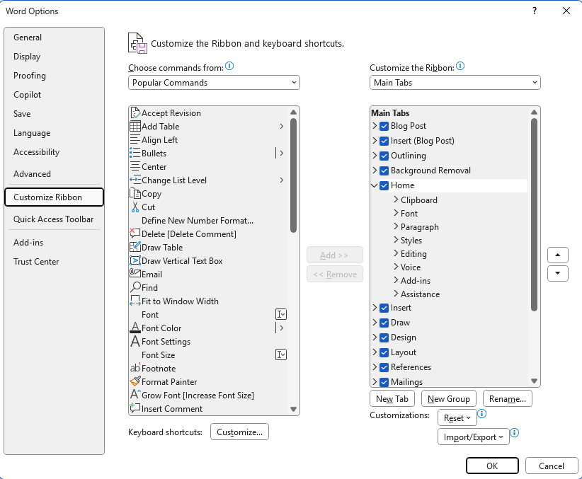
Figure 15 shows the Customize Keyboard dialog box. To assign Keep with next to a keyboard shortcut of Alt + K, use the following steps:
- scroll down the Categories: memo box until you find All Commands (it is near the bottom) and select it; alternatively, once you have you can rapidly type “all” and then select All Commands
- place your cursor in the Commands: memo box and rapidly type “Para”; this will take you to the first of the Para commands (ParaDown) on my computer
- scroll down to ParaKeepWithNext and select it
- click in the Press new shortcut key: edit box (below the Commands: memo box)
- hold down the Alt and K keys together; “Alt+K” will appear in the edit box
- press the Assign button at the bottom left, and the assignment will be completed.
Note that if ParaKeepWithNext has already been assigned a shortcut key, this will be displayed in the Current keys: memo box (as is the case in Figure 15, since I had previously made this assignment). Also, if the Alt + K keyboard shortcut is already in use, it will show next to the Currently assigned to: label beneath the Current keys: memo box. Again, this is the case in Figure 15.
Similarly, I normally assign ParaPageBreakBefore to a shortcut of Alt + P. Since it is immediately below ParaKeepWithNext in the Commands: memo box, it is convenient to do it at the same time.
Figure 15 – Assigning Alt + K to be shortcut key for Keep with next
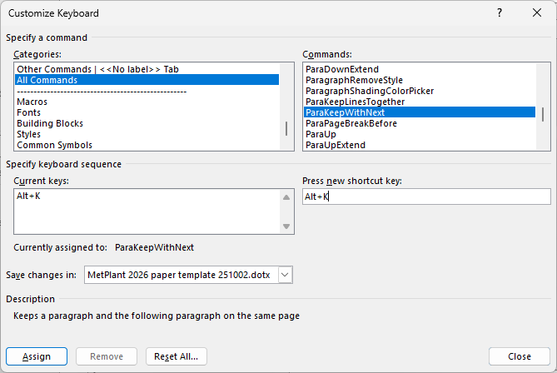
The Keep with next property is also useful to stop tables splitting across pages. You do this by switching on the property in every row, except the final row, in the first column of the table. Leave the Keep with next property switched off in the final row so that the table does not follow the next paragraph to a new page.
Note that Keep with next keeps a paragraph with the next paragraph mark. If you create a space between paragraphs by pressing the Enter key, this will create a new paragraph mark, and Keep with next will, in the example shown in Figure 11, keep the heading “Keep with Next” with the space and not the words that you typed. For this reason, avoid creating spaces between paragraphs by hitting the Enter key twice.

Inserting Captions and Cross-references

Creating a caption
Captions can be created from the References ribbon, using the Insert Caption icon (see Figure 16). This opens a dialog box from which to select the appropriate caption (Figure 17). Normally, the only options are Equation, Figure and Table. However, I created a fourth caption title, Appendix, using the New Label button to allow me to cross-reference the appendices in this document.
Figure 16 – Insert Caption
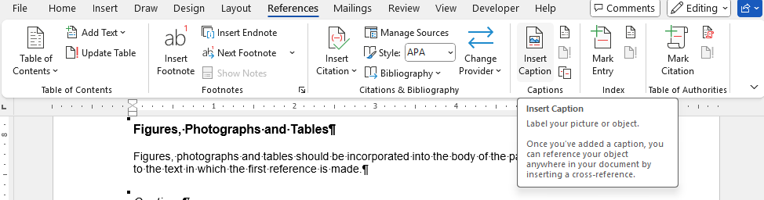
The keyboard shortcut for inserting a caption is by pressing and releasing Alt, then I, then N and finally C. If you incorrectly press Alt + I simultaneously, you will activate Copilot.
Select the appropriate label from the Label dropdown box, press OK, and the caption will appear at the point in the text where you have your cursor.
Figure 17 – Caption dialog box
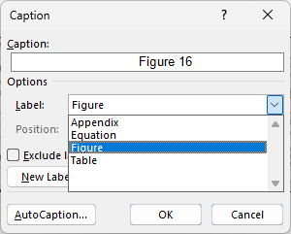
Captions must be above the figures, photographs and tables (see Figure 18 for an example). While figure and photograph captions have traditionally been below the figures or photographs, having them above makes it easier to format the document using the Keep with next property and people reading the document on a computer will first read the caption and then see the item to which it refers.
The Caption style in the template has been formatted with the Keep with next property switched on (see Keep with Next in Appendix 2; page 22). This means that the caption will stay with the next paragraph (i.e., the figure, photograph or the first line of a table).
The Caption style has also been formatted to have a 12 pt space ahead and behind it to create a space between the caption and the item to which it refers.

Creating a cross-reference
You insert a cross-reference through the Insert Cross-reference button, which is the one at the bottom right of the Captions grouping on the References ribbon (see Figure 18).
Figure 18 – Insert Cross-reference
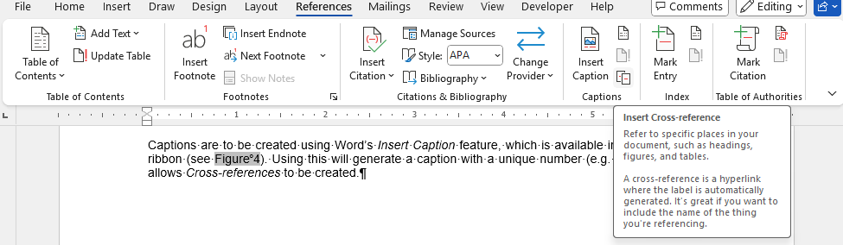
When you select Insert Cross-reference, a dialog box will open allowing you to select from a menu of items to which a cross-reference can refer (see Figure 19). Selecting Figure in Figure 19, displays a list of figures in the document to which a cross-reference can be made. It is important to select Only label and number from the Insert reference to: drop-down box. The default is Entire caption, and this results in the label, number and caption text being reproduced in the document.
Figure 19 – The Insert Cross-reference dialog box
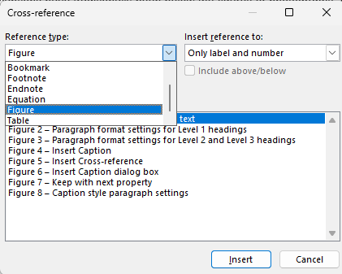

Cross-references to footnotes and endnotes
Cross-references to footnotes and endnotes are created through the same Cross-reference dialog box as cross-references to captions (see Figure 18); however, the Insert reference to: list box options are different (see Figure 20). Use the Footnote number (formatted) option shown in Figure 20. This will create a footnote cross-reference that will be superscripted automatically; using Footnote number results in a normal text number that must be superscripted manually.
Figure 20 – The Insert Cross-reference dialog box options for footnotes and endnotes
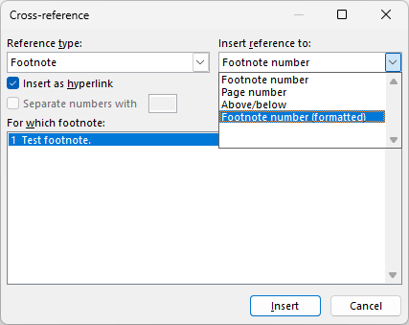

General Handy Hints for Word

Autoformatting subscripts and superscripts
Word’s AutoCorrect function provides a handy way to convert numbers in formulae or unit symbols to subscripts or superscripts as you type them.
To make this happen, use the following steps:
- type the formula, e.g., Fe2O3
- if Word indicates that the formula is a spelling error, right click on it to add it to your dictionary
- manually convert the numbers to subscripts or superscripts, e.g., Fe₂O₃ or Nm³/s
- select the formula with its subscripts
- open the AutoCorrect dialog box, and the selected text will appear in the With edit box (see Figure 21); this will not work this way if the formula is treated as a misspelling
- select the Formatted text radio button
- type the formula into the Replace edit box
- select Add and then OK.
Figure 21 – Autocorrect dialog box
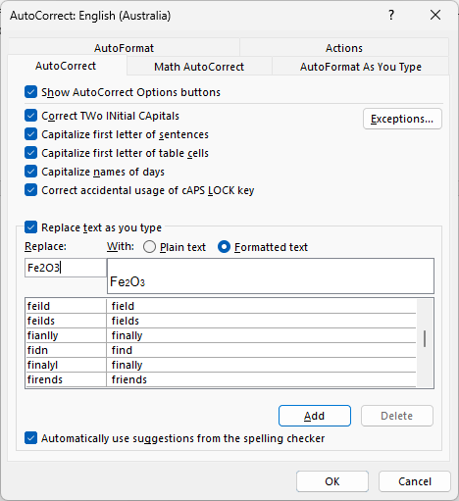
Once you have followed these steps, each time you type the formula or unit, it will automatically subscript or superscript the numbers.
Note that AutoCorrect is language-specific, so if you switch dictionaries (e.g., from English (Australia) to English (United States)), you will need to re-enter the formulae when you first use them.

Creating an en dash
If you have a numeric keypad, the easiest way to create an en dash is to press a Ctrl and the numeric keypad minus key simultaneously. Another route is to hold down an Alt key while typing 0150 on the numeric keypad.
If you do not have a numeric keypad, you can create an en dash by using the default AutoCorrect option of typing a character, then a space, then a hyphen, then a second space, then another character and finally a space or some punctuation mark. The result will be something like “word – second word”. If you are using the en dash to indicate a range, e.g., 27–32, you would then need to delete the spaces either side of the en dash.
A fourth way to create an en dash is to use the Symbol dialog box from the Insert ribbon (see Figure 22). You could use this to create your own keyboard shortcut using the Shortcut Key… button.
Figure 22 – The Symbol dialog box
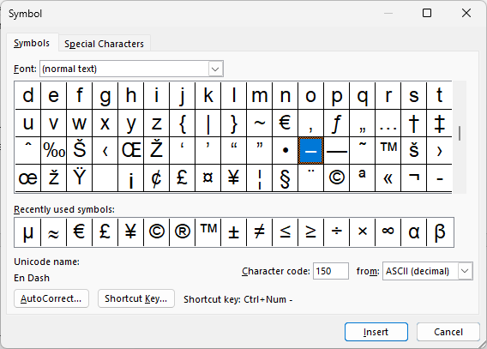
Appendix 3

Spelling and Hyphenation of Technical Terms
Table 8 – Examples of spelling and hyphenation of technical terms
ball mill | on-site
Bypass | open cut
cost-effective | ore dressing
Dialog | orebody
drill core | outcrop
drill hole | overall
et al | overflocculated
flow chart | per cent
flow sheet | pre-existing
Flocculant | program
fly-in, fly-out | reagent
Gram | recleaning
impeller | recognise
in situ | regrind
in-depth | rock-crushing plant
iron ore deposit | screen-sizing test
jaw crusher | self-actuated
lead–zinc ore | short-term
liquid–solid separation | sink-float system
long-term | solid–liquid interface
low-grade | start-up
mine site | sublevel
multilevel | sulfide
non-metallic | sulfur (also related terms)
offline | test work
offshore | time frame
off-site | trialled
one-half | two-thirds
one-twentieth | world-class
ongoing | worldwide

List of Abbreviations
Table 9 – List of commonly-used abbreviations
A$ | Australian dollar | mol wt | molecular weight
atm | atmosphere/atmospheric | mol | mole (amount of substance)
cf | compare | mol | molecule/molecular
cm | centimetre | mol/L | moles per litre
cm/s | centimetre per second | µg | microgram
cm² | square centimetre | µ | micron
cm³ | cubic centimetre | µm | micrometre
cm³/s | cubic centimetre per second | M | million
coeff | coefficient | ms | millisecond
e.g. | for example | Mt/y | million tonnes per year
etc | et cetera | mV | millivolt
€ | Euro | MW | megawatt
ft | foot/feet | N | Newton, north
g | gram | NB | note well
G | Newtonian constant of gravitation | No(s) | number(s)
g/L | grams per litre | NPV | net present value
Hz | Hertz = frequency | op cit | in the same place previously cited
ibid | in the same reference | p/pp | page/pages
i.e. | that is | Pa | pascal
in | inch(es) | Pat | patent
J | Joule | % | per cent
K | degree absolute (Kelvin) | per cent | not abbreviated in text
kg | kilogram | pers comm | personal communication
kJ | kilojoule | pH | measure of acidity or alkalinity
kPa | kilopascal | Rad | radian/radius
kV | kilovolt | rev | revolution
kW | kilowatt | rev/min | revolutions per minute
kWh | kilowatt hour L | SD | standard deviation
L/s | litre per second | Sic | incorrectly written in the original
liq | liquid | Sq | square
m | metre | t/y | tonne per year
m/s | metre per second | t/d | tonne per day
m² | Square metre | t/h | tonne per hour
m³ | cubic metre | t/mth | tonne per month
m³/h | cubic metre per hour | Tan | tangent
m³/min | cubic metre per minute | Temp | temperature
max | maximum | t | tonne or tonnes
mg | milligram | US$ | US dollars
MHz | megahertz | w/v | weight for volume
min | minimum, minute | w/w | weight for weight
ml | millilitre | wk | week
mm | millimetre | wt | weight
mm² | square millimetre | y | year
mm³ | cubic millimetre

Appendix 4

Template for paper
The following page is a starting point for the paper. Delete all the preceding pages before submitting the paper and save the paper in the *.doc or *.docx format.

Title of Paper
A Author¹, B Author², C Author³
1. Position title, Organisation name, Address, Email address
2. Position title, Organisation name, Address, Email address
3. Position title, Organisation name, Address, Email address

Abstract
Text here

Introduction
Text here

Level 2 heading
Text here

Level 3 heading
Text here

LEVEL 1 Heading

Use ® for a trademark that is registered, and TM for a trademark that has not been registered.
For a way to take the drudgery out of subscripts and superscripts, see Autoformatting subscripts and superscripts (page 28) in Appendix 2.
Depending on the spelling checker option selected.
If you do not know how to generate an en dash, see Creating an en dash (page 30) in Appendix 2.
J.R. Boldt, The Winning of Nickel (Van Nostrand, New York, 1967) 27–32.
J.T. Woodcock and J.K. Hamilton, Eds, Australasian Mining and Metallurgy: The Sir Maurice Mawby Memorial Volume, Second Edition (The Australasian Institute of Mining and Metallurgy, Melbourne, 1993).
L.E. Anderson, “Copper ore concentration at Kanmantoo, SA” in Mining and Metallurgical Practices in Australasia, (Ed: J.T. Woodcock), The Australasian Institute of Mining and Metallurgy, Melbourne, 314–315, (1980).
D.J. Readett, K.B. Quast, R. Newell, S.F. Hill, and I.B. Ketteridge, “Modelling the leaching of NaCl from Bowmans lignite” in Proceedings of Research and Development in Extractive Metallurgy 1987, J.T. Woodcock and D.R. Parker, Eds (The Australian Institute of Mining and Metallurgy, Melbourne, 1987), 273–277.
C.D. Barnes, P.T. Griffin, and S.M. O’Hare, “Copper concentrator practice at Mount Isa Mines Limited, Mount Isa, Qld”, The AusIMM Proceedings, 298 (1) 27–19 (1993).
D.C. Hamdorf, “The Australasian Institute of Mining and Metallurgy review of ethics policy”, The AusIMM Bulletin, (1) 6–7 (1993).
M. Denholm, “Waters’ tacit support for damaging renewables”, The Weekend Australian, (October 4–5) 1,8 (2025).
S. Author, M. Author, H. Author, “Title of preprinted paper”, DOI (2026).
I.H. Warren, “The generation of sulfuric acid from pyrite by pressure leaching”, Australian Journal of Science (in press).
M.J. Lees, “Experimental and computer studies of a grinding circuit”, unpublished thesis, University of Queensland (1973).
I.M.A. Clark, Personal communication, 24 January 1994.
R.L. Player, S.P. Matthew, J.M.I. Tuppurainen, “Method of extracting valuable metals from leach residues”, AU-B-82897/91, PCT Publication Number WO92/02648, 23 June 1994.
US Department of the Interior, US Geological Survey, Mineral Commodity Summaries 2025, Version 1.2, March 2025. https://pubs.usgs.gov/periodicals/mcs2025/mcs2025.pdf. Accessed 5 October 2025.
R. Suzuki, “Workers’ attitudes toward computer innovation and organization culture: the case in Japan”, paper presented to 10th World Congress of Sociology, Mexico City, 16–21 August 1982.
S. Klaas, “Applying chaos theory to long-distance delivery services”, Delivery Research Station, North Pole, AK 99705 (in preparation).
B.J. Amos and F. de Keyser, “Mosman, Queensland – 1:250 000 geological series, Bureau of Mineral Resources Geology and Geophysics Explanatory Notes, SE55–1 (1964).
Alt + T, release and press A.

